**Project Design Phase-II**

**Data Flow Diagram & User Stories**

|  |  |
| --- | --- |
| Date | 31 January 2025 |
| Team ID | SWTID1741257268149879 |
| Project Name | InsightStream: Navigate the News Landscape |
| Maximum Marks | 4 Marks |

**Data Flow Diagrams:**

A Data Flow Diagram (DFD) is a traditional visual representation of the information flows within a system. A neat and clear DFD can depict the right amount of the system requirement graphically. It shows how data enters and leaves the system, what changes the information, and where data is stored.

**Example:**

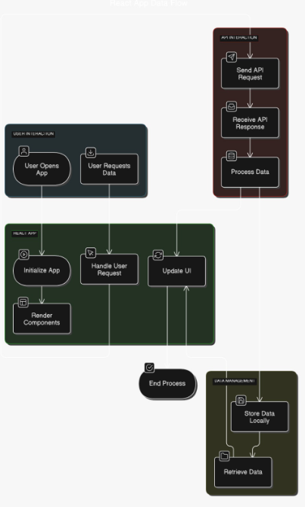

**User Stories**

**User Story Table –** InsightStream: Navigate the News Landscape

|  |  |  |  |  |  |  |
| --- | --- | --- | --- | --- | --- | --- |
| **User Type** | **Functional Requirement (Epic)** | **User Story Number** | **User Story / Task** | **Acceptance Criteria** | **Priority** | **Release** |
| **News Reader** | Trending News | USN-1 | As a user, I can see the trendy news. | I can see the news of all topics. | High | Sprint-1 |
| **News Reader** | News by Genre | USN-2 | As a user, I can watch Political, Business, and Technology News. | I can also go to the source and read the full news. | High | Sprint-1 |
| **News Reader** | Global News | USN-3 | As a user, I can view complete news coverage across the world. | I can navigate multiple pages to explore more news. | Medium | Sprint-2 |
| **Subscriber** | Subscription | USN-4 | As a user, I can subscribe to news updates. | I can subscribe to the newsletter for news updates. | High | Sprint-2 |